# Findings

* Tutorial Setup (AWS Script) 🡪 2327 Lines

## Frankfurt geht nicht, US-1 geht:

* 1st try to setup AWS: Failed   
    
  🡪 Why? Where can I find the reason?  
  🡪 No Output…  
  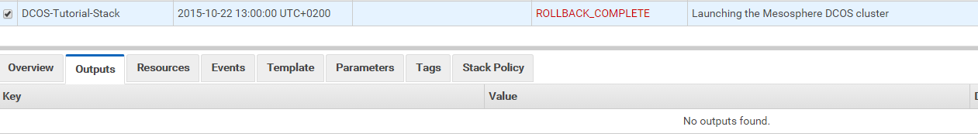
* 2nd try also failed (after updating credit card information):  
    
  🡪 Eventually missing services in Frankfurt?   
  🡪 did I check 🡪  
  🡪 try again making sure above is checked…
* Europe not really not working: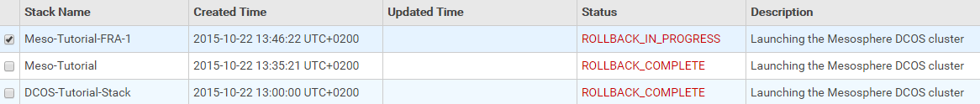  
  🡪 try US-west-1 next…
* US-1 klappt:  
  
* [**Outputs**](https://console.aws.amazon.com/cloudformation/home?region=us-west-1)

| **Key** | **Value** | **Description** |
| --- | --- | --- |
| DnsAddress | Meso-Tuto-ElasticL-P7B6N0QCBLUS-554225263.us-west-1.elb.amazonaws.com | Mesos Master |
| PublicSlaveDnsAddress | Meso-Tuto-PublicSl-1DV84PC49RTNI-193387908.us-west-1.elb.amazonaws.com | Public slaves |

Master: Meso-Tuto-ElasticL-P7B6N0QCBLUS-554225263.us-west-1.elb.amazonaws.com

## Security ;-(

No password was asked to manage dcos:

<http://meso-tuto-elasticl-p7b6n0qcblus-554225263.us-west-1.elb.amazonaws.com/#/services/>

## Setup not as smooth as expected under Unix

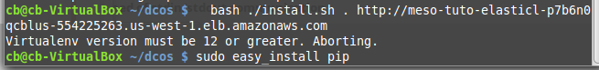



pip install virtualenv

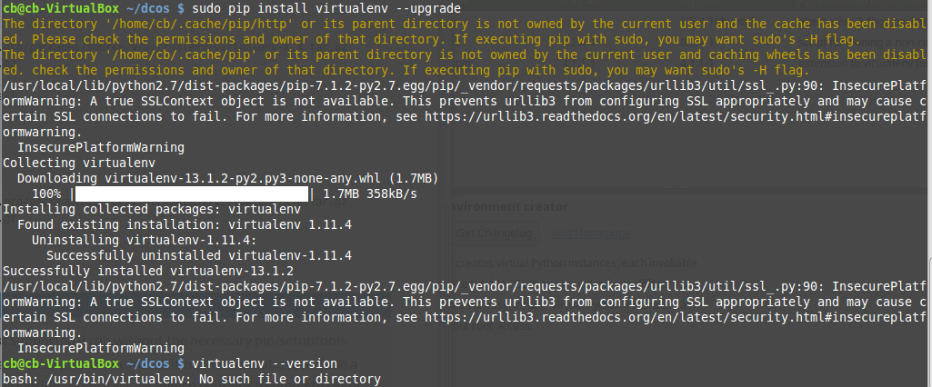

## Chat Support pretty good, but large instances are required.

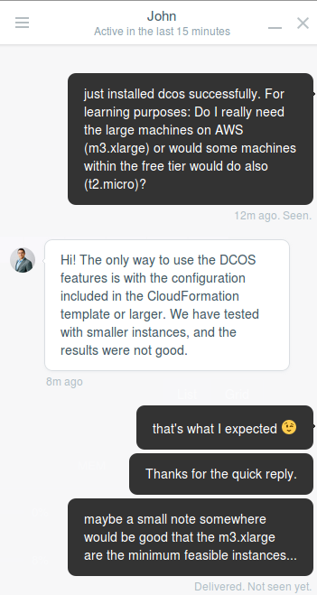

## After stopping instances, they seem to be terminated

History:

* Stop all 8 instances
* Click in “Launch instance”
* Go back (as I would likely create new instances)

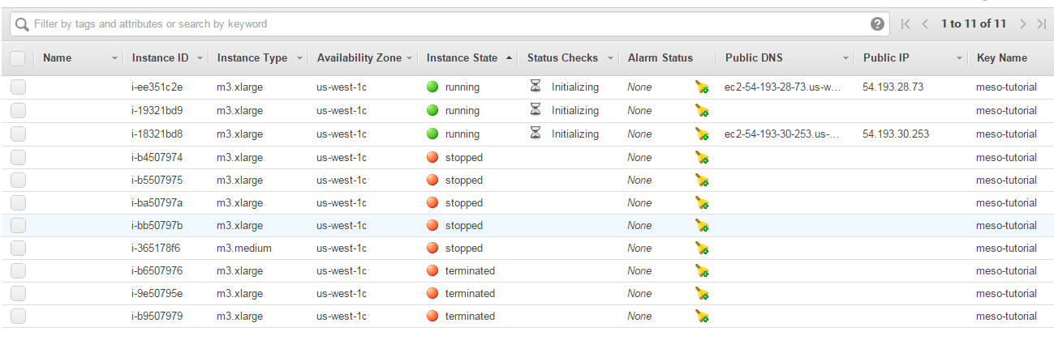

Startup takes several minutes…

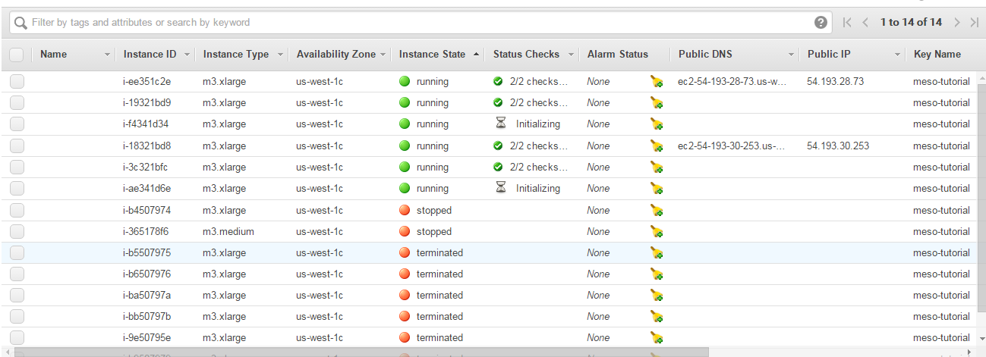

* All apps are gone…
* Interesting: Two node did not start automatically (forgotten to check?)  
  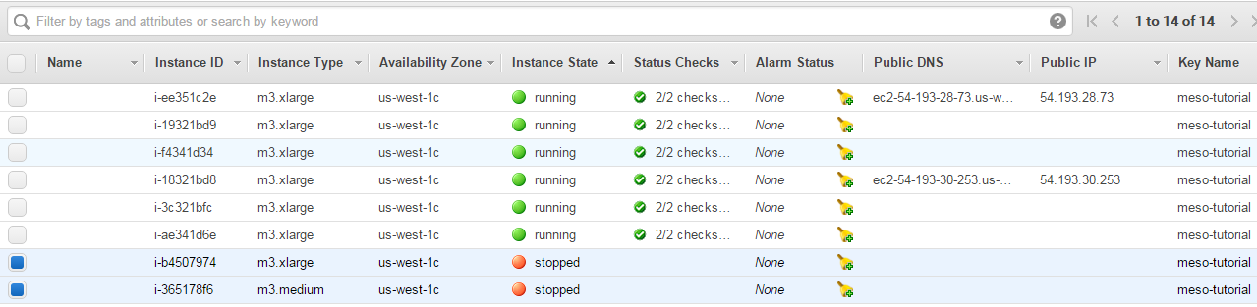  
  🡪 but dcos dashboard is there with 1 node only (instead of 5 nodes as it was before):  
  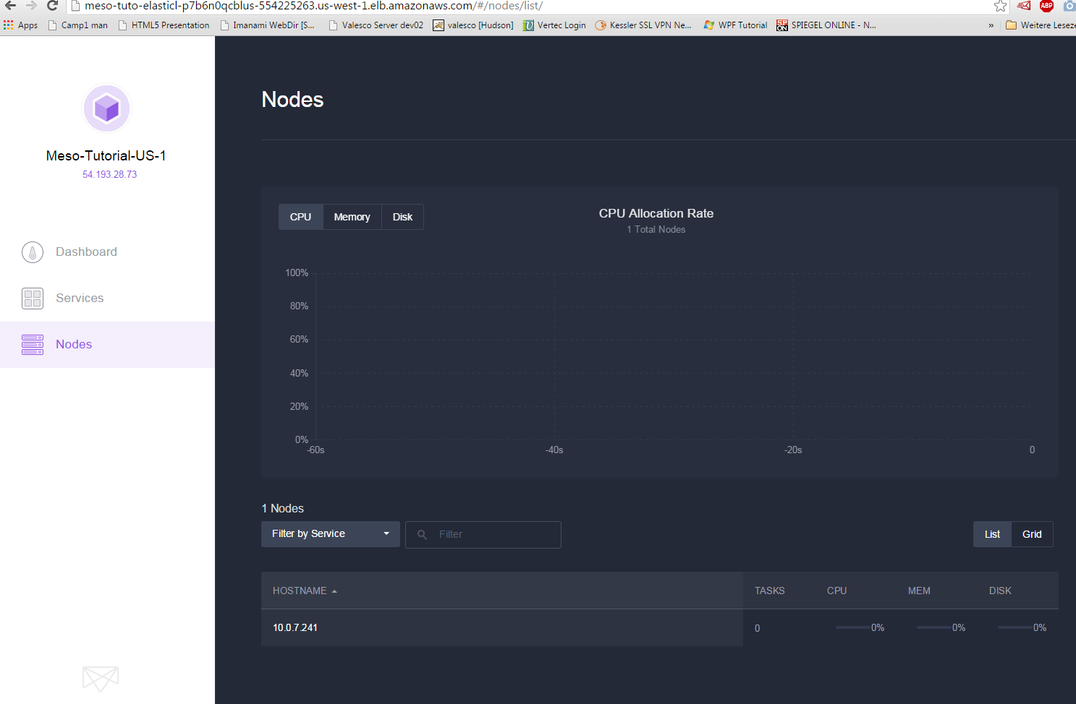  
    
  🡪 let’s start the two offline nodes manually…  
  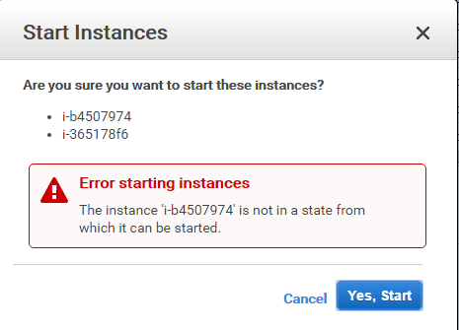  
  🡪 only this one succeeded: i-365178f6
* After start of , all 6 nodes were visible again:  
  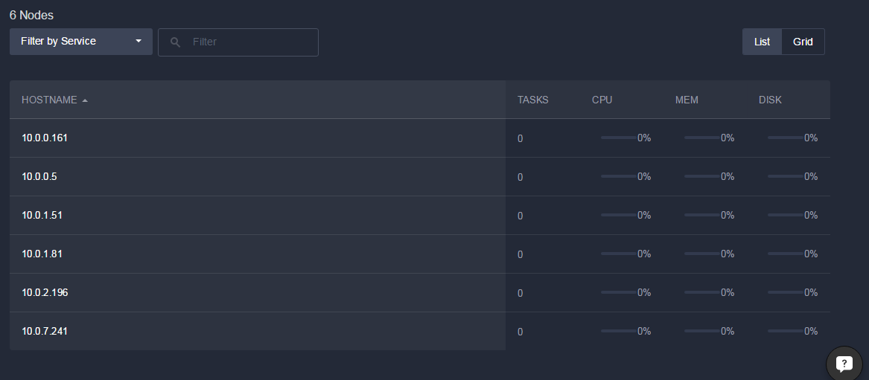
* But still no apps…

### Stop/Start need EBS backed root volume

<http://docs.aws.amazon.com/AWSEC2/latest/UserGuide/Stop_Start.html>

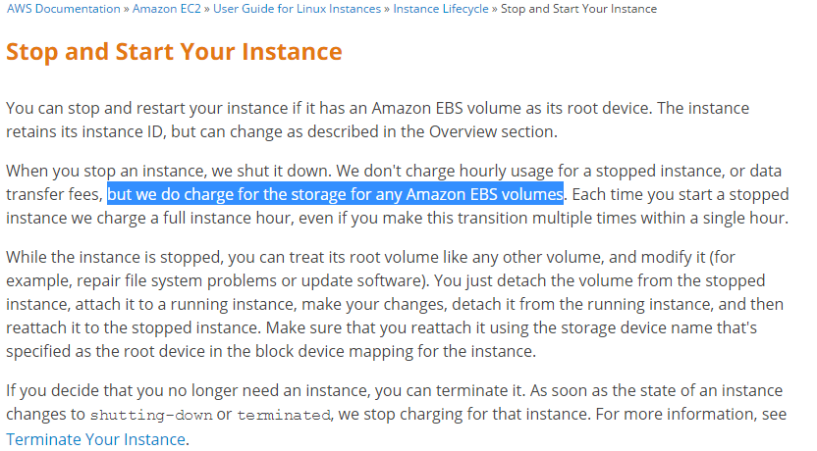

### Stop 2 slave nodes in AWS frontend

* Stop 2 nodes (likely slave workers as no DNS entry)  
  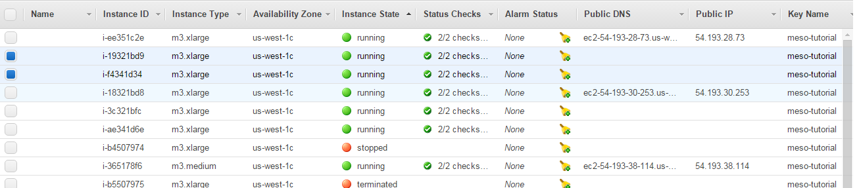  
  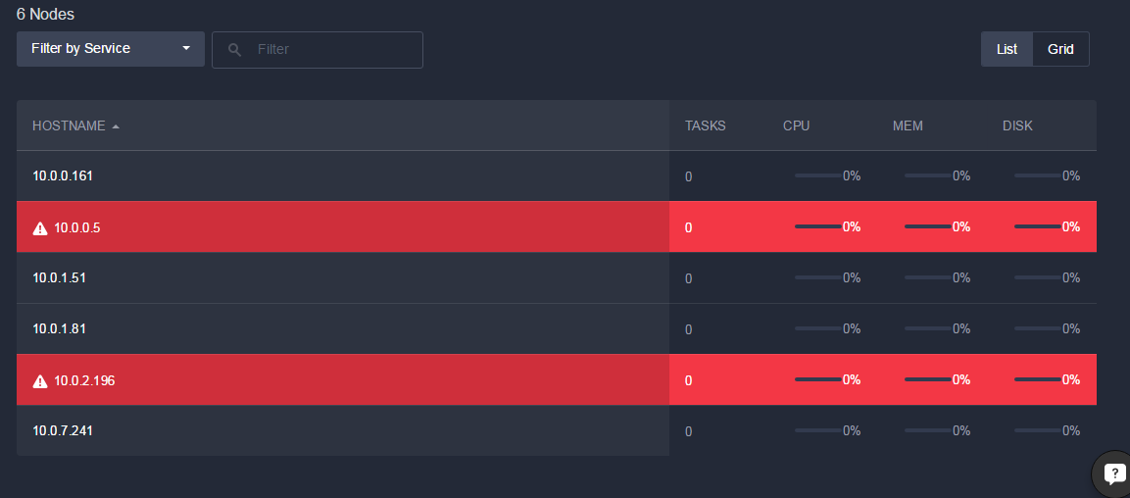

### Install everything again 🡪 Cassandra unhealthy

  
🡪 Why?  
🡪After some minutes 🡪 Healthy ;-)

### DCOS seems to create nodes automatically in AWS

After stopping 2 nodes and without clicking or typing anything, 8 nodes are present again…

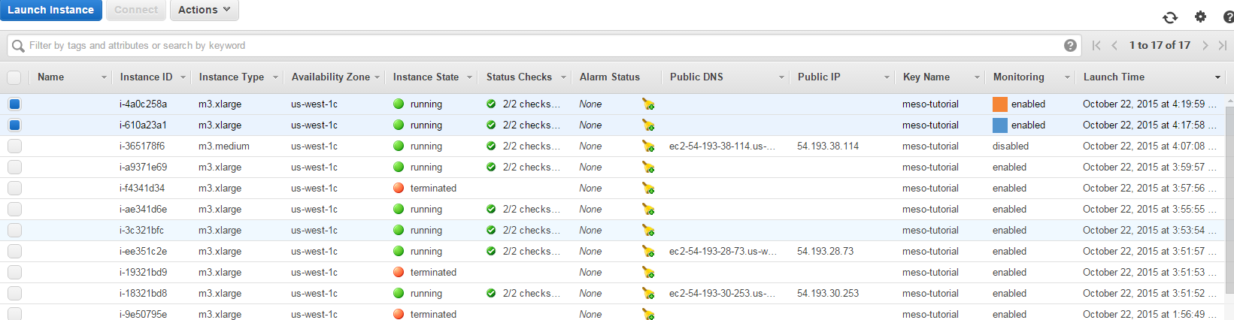

### In theory we should have EBS storage in use:

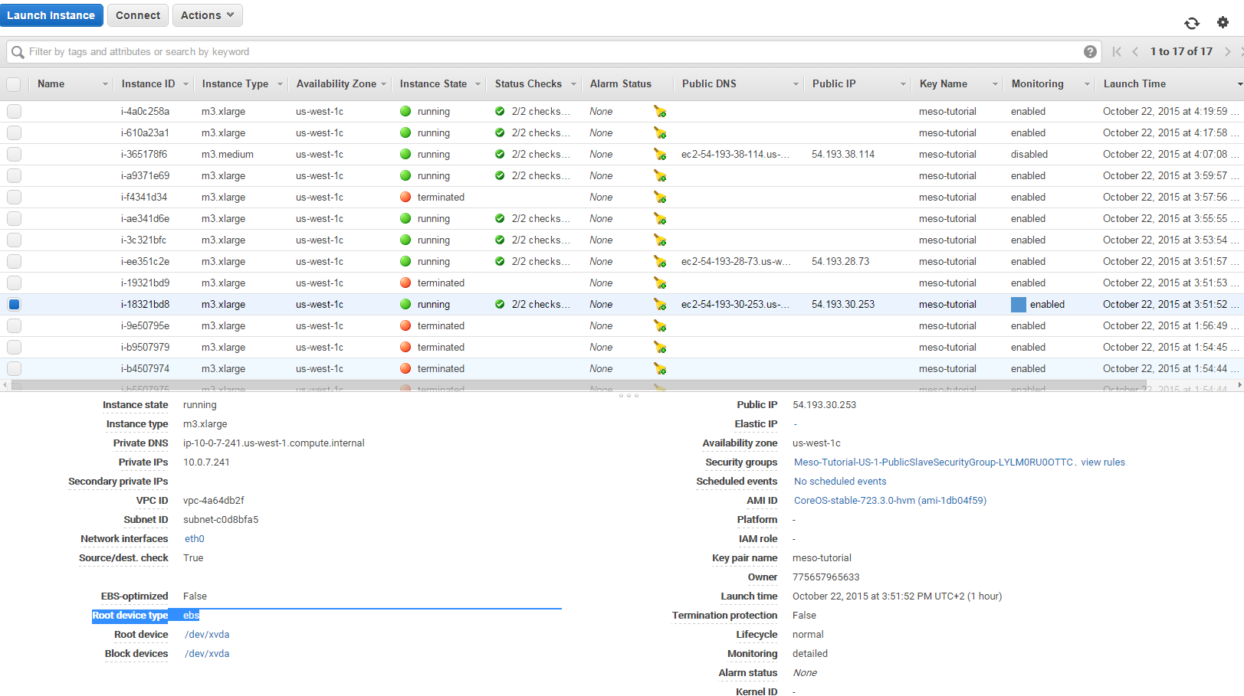

* Root device type is “ebs” for all instances!
* To be found as “Volumes” in EC2 dashboard:  
  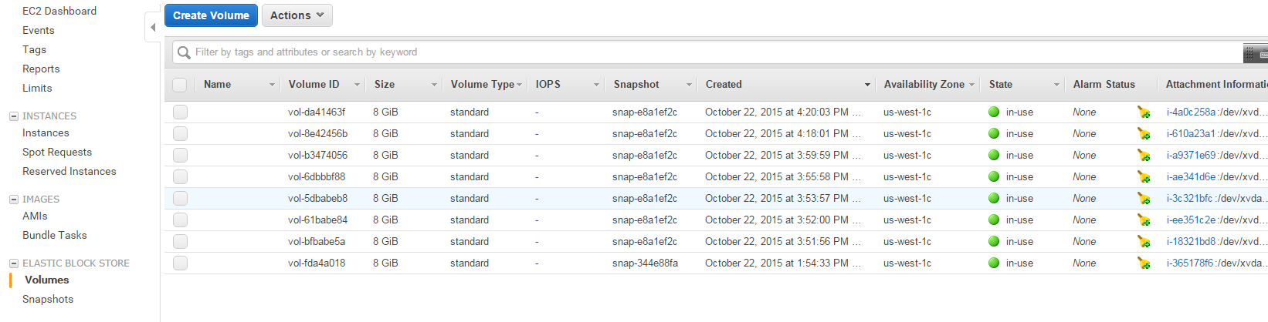

### Stop in AWS terminates (again)

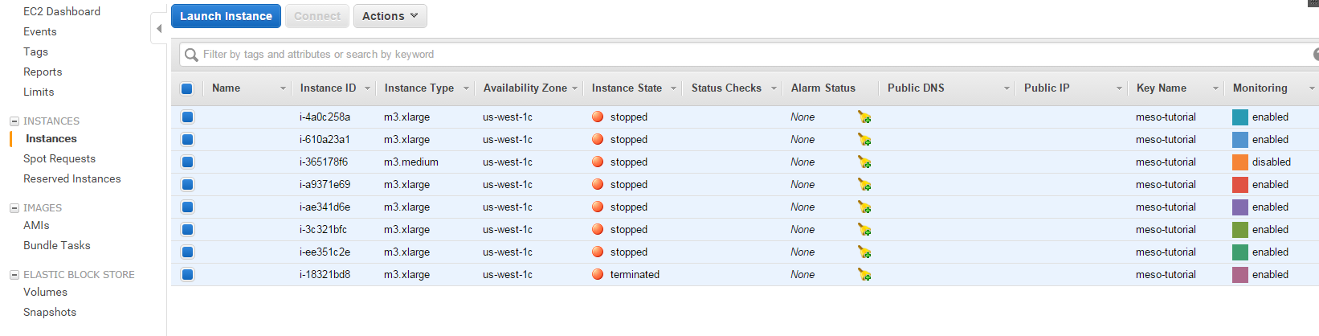

… and restarts automatically new instances!!!  
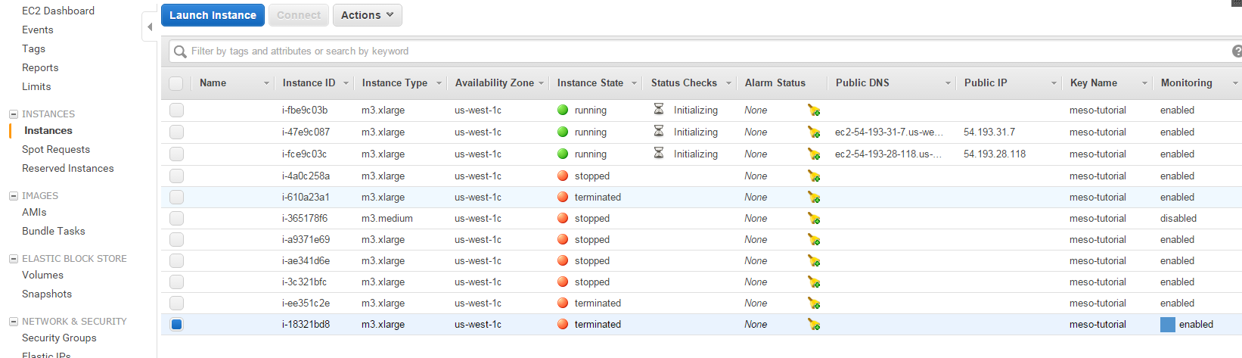

… even terminating all does not help

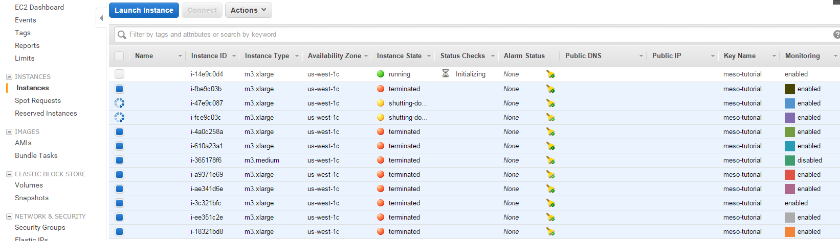

… terminate does not help!

Try delete keypair….

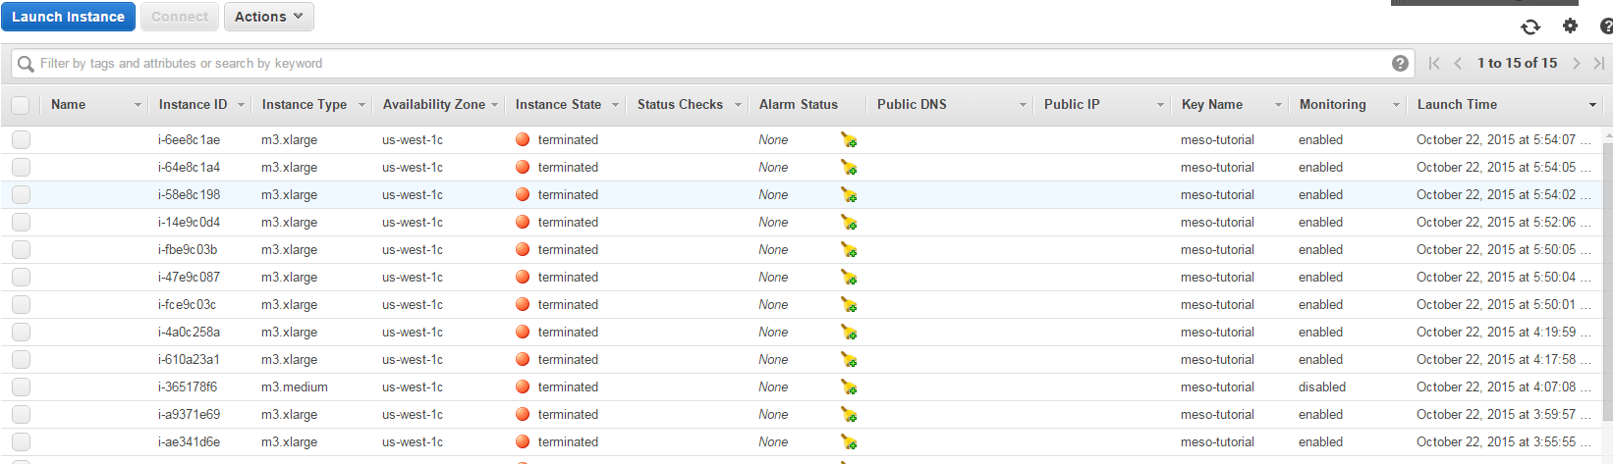

* Only thing working
* And it likely was not the “Cloud Formation” thing (no events at 5pm)  
  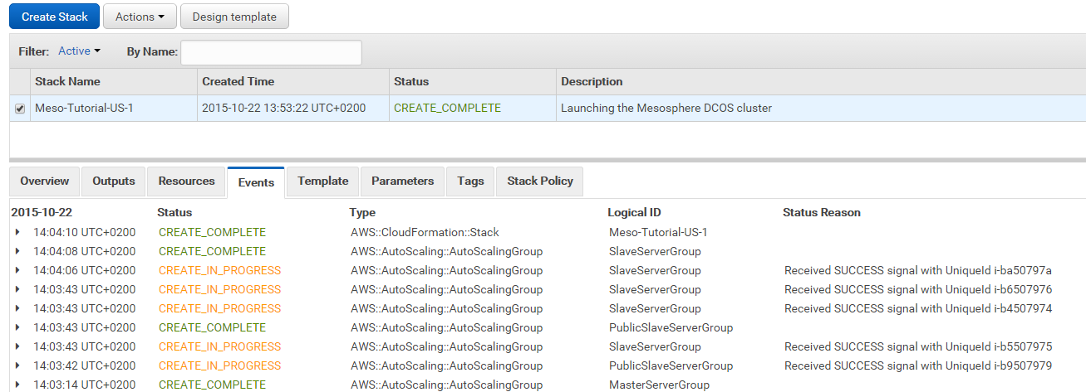

### Found answers in stackoverflow



See <http://stackoverflow.com/questions/31848810/mesososphere-dcos-cluster-on-aws-ec2-instances-are-terminated-and-again-restart>

Maybe the autoscaling group is the answer:

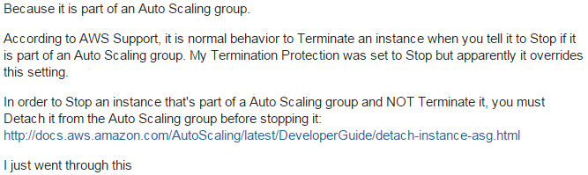

see: <http://stackoverflow.com/questions/19194893/why-does-my-aws-ec2-instance-terminates-when-stopped>

Detach instances from autoscaling group:

<http://docs.aws.amazon.com/AutoScaling/latest/DeveloperGuide/detach-instance-asg.html>

* Yes. This is the reason: The setup created autoscaling groups!

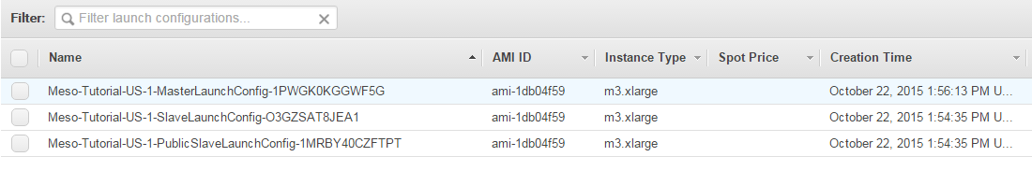

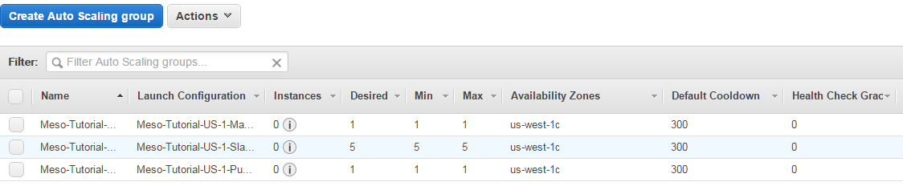

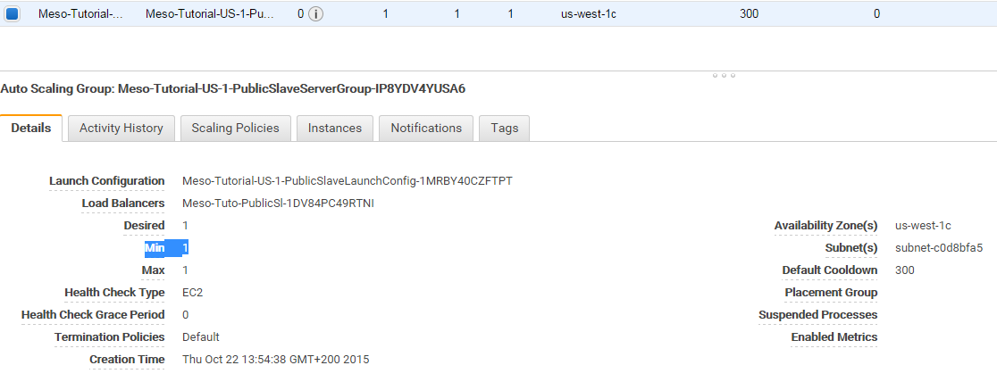

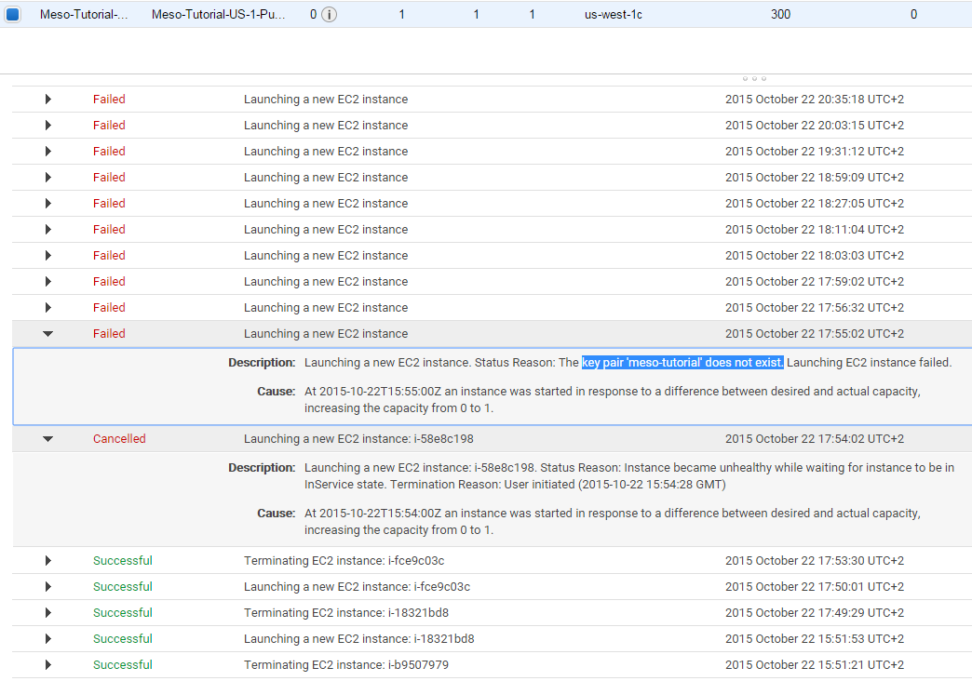

### Answer from Chat:

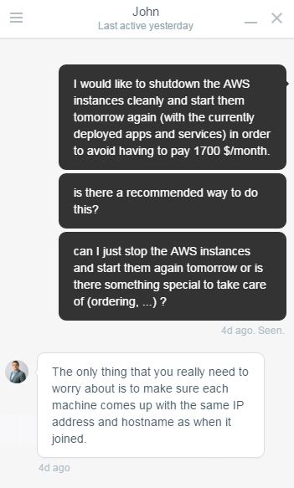

## Circular dependencies between security groups

… make it pretty hard to delete them – at least by hand.

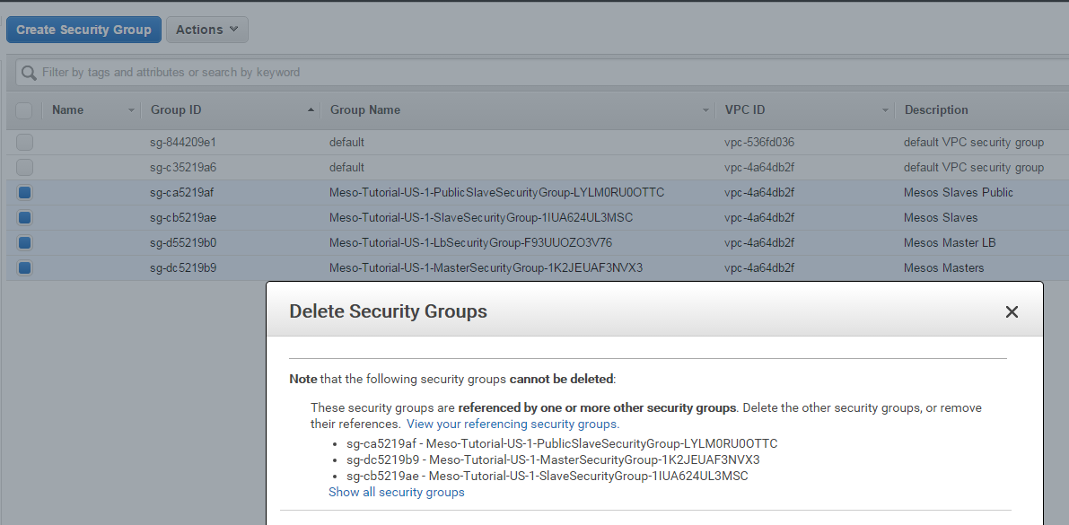

References:

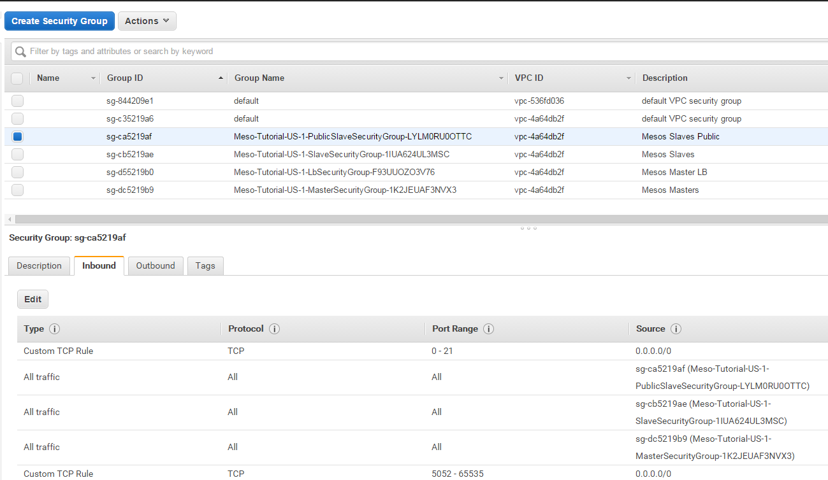

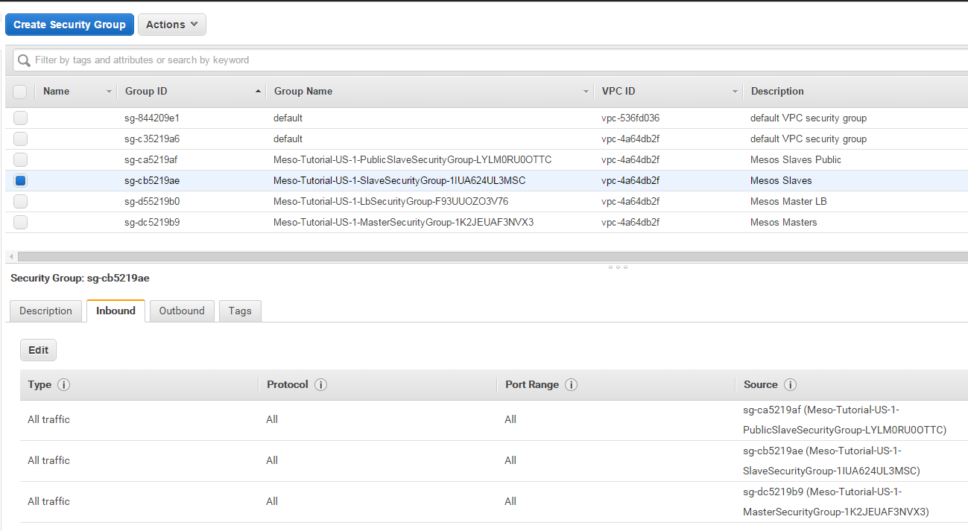

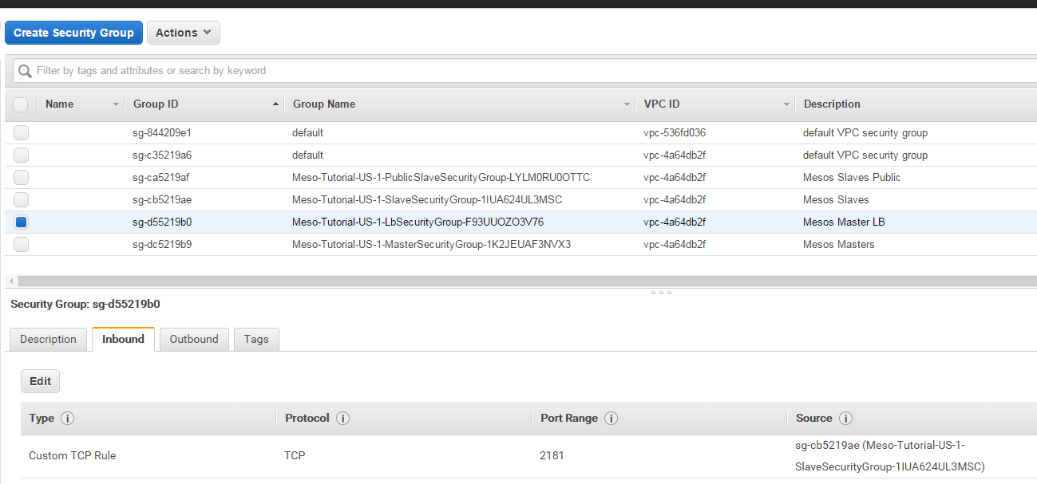

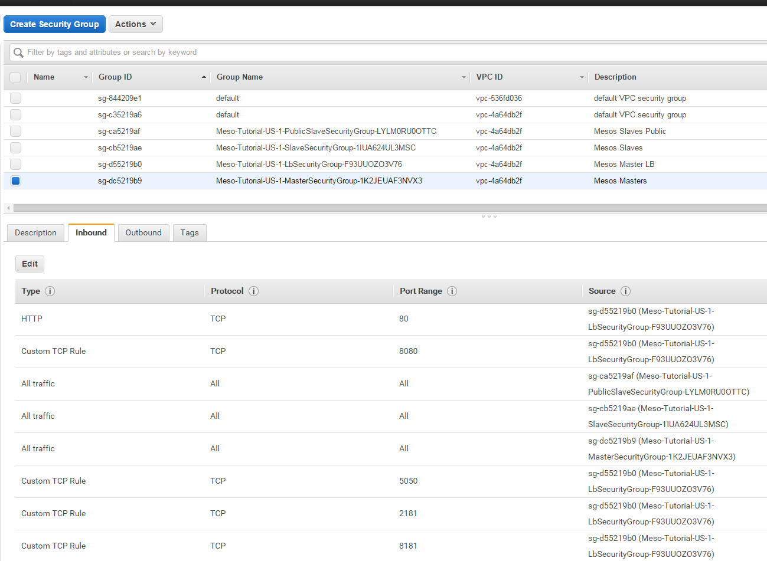

Master

Master  
Loadbalancer

Public Slave

Slave

Does this match the [theory](https://docs.mesosphere.com/overview/dcosarchitecture/)?

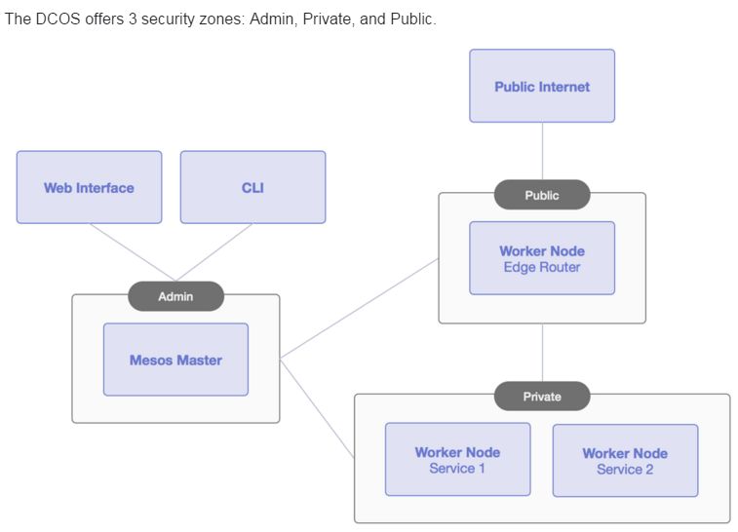

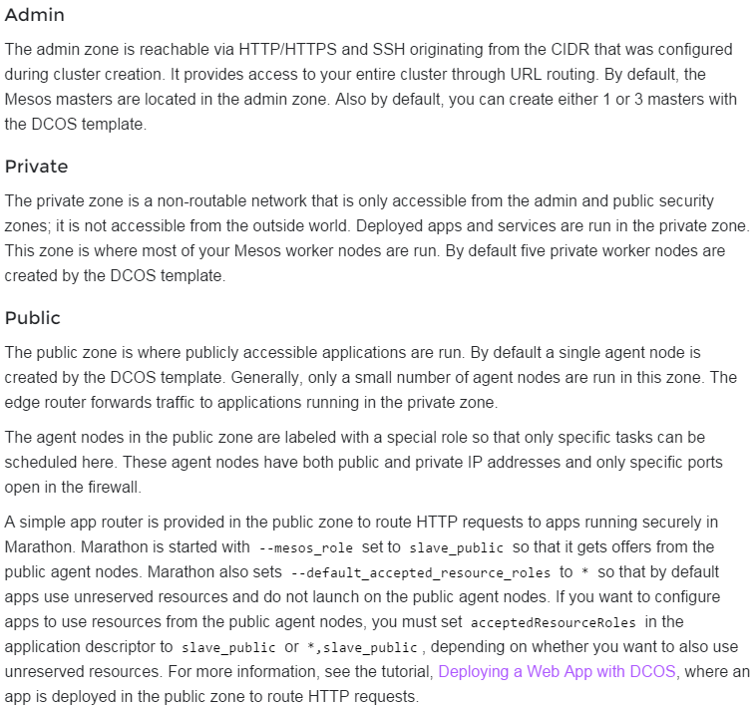

## What happens (to Cassandra) if only 1 slave exists?

Cassandra stays unhealthy (likely reason: wants to start 3 instances)  


Question:

* Is it possible to start with 1 Node in SlaveServerGroup and scale up?
* OR do we have to start with several instances and scale down?  
  🡪 What if we scale up again?

### Try Scale-UP from 1 to … nodes to make Cassandra healthy:

#### Setup with 1 Slave instance:

<https://console.aws.amazon.com/cloudformation/home> :  
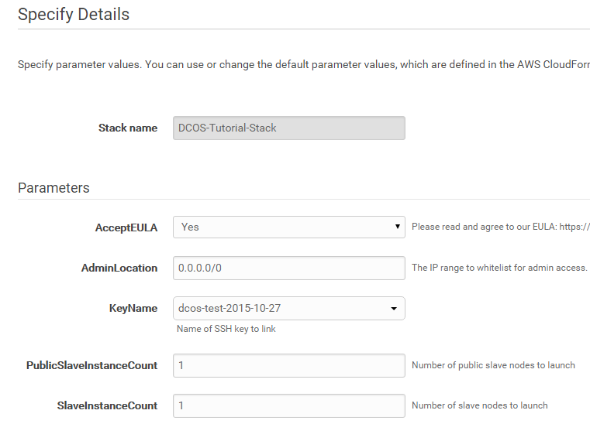

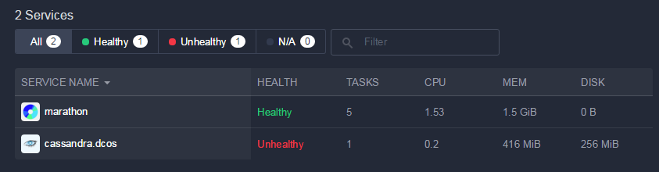

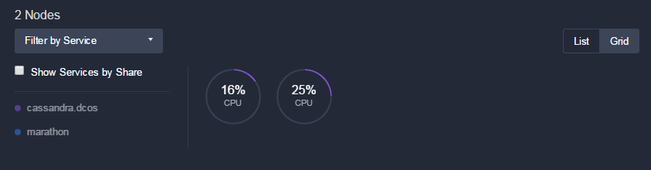

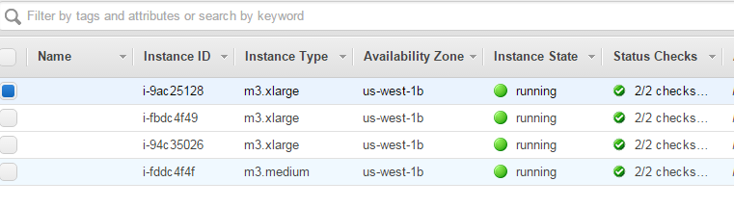

EC2 Instances:

* 1 x MasterServerGroup
* 1 x SlaveServerGroup
* 1 x PublicSlaveServerGroup
* 1 x NATInstance

Likely the 2 nodes shown in DCOS Dashboard are 1 x SlaveServerGroup + 1 x PublicSlaveServerGroup

#### Upgrade to 2 instances in SlaveServerGroup

<https://console.aws.amazon.com/cloudformation/home>

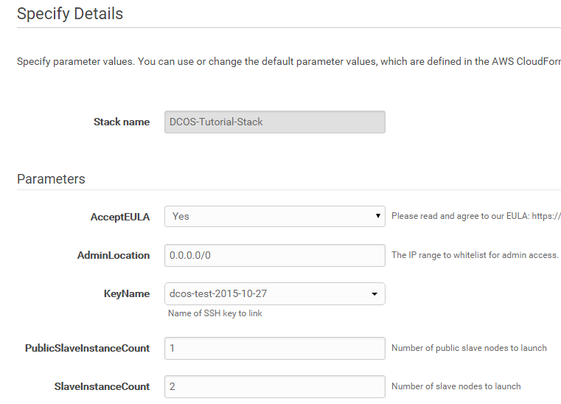  
  
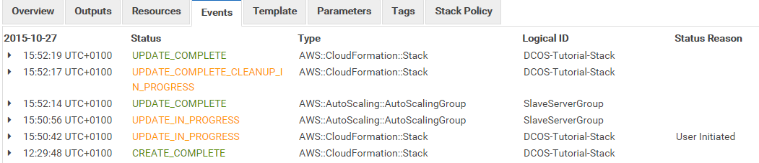

… wait 10 Minutes to see whether Cassandra becomes healthy …

DCOS Dashboard:

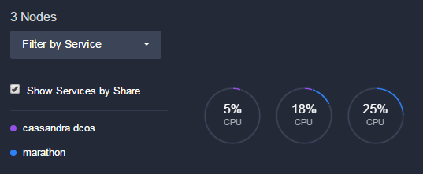

Cassandra still unhappy after 17 Minutes:  
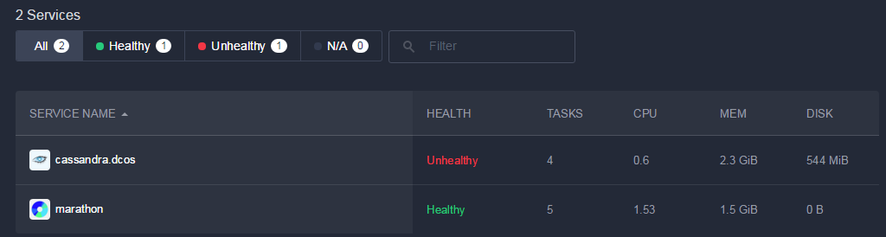

#### Upgrade to 3 instances in SlaveServerGroup 🡪 Cassandra healthy

<https://console.aws.amazon.com/cloudformation/home>

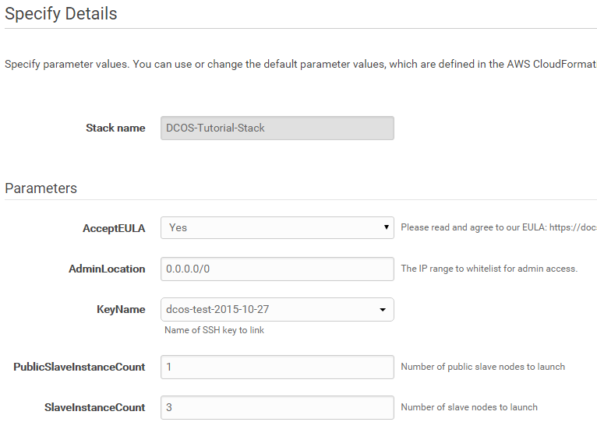

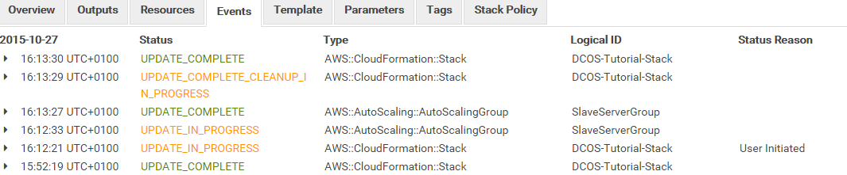

Cassandra now healthy ;-)

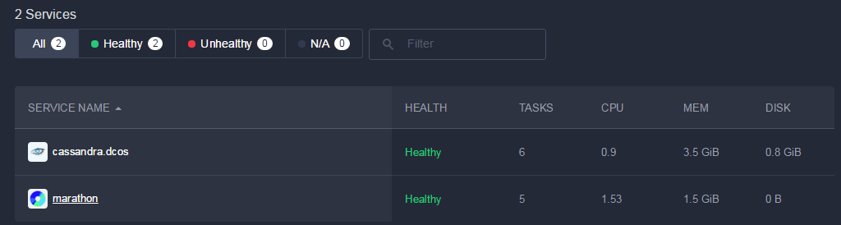

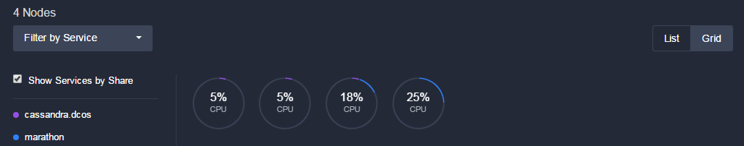

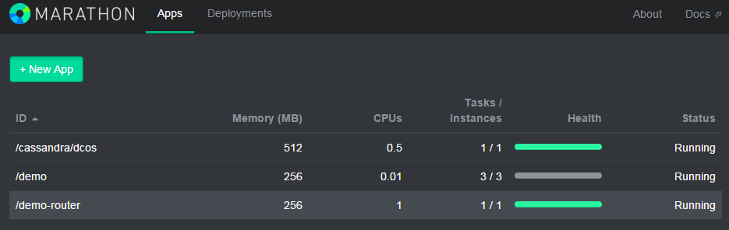

#### Downgrade to 2 instances in SlaveServerGroup

<https://console.aws.amazon.com/cloudformation/home>

  
  
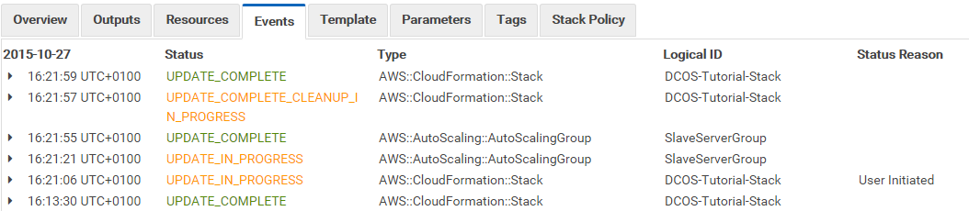

* Cassandra unhealthy again
* Cassandra needs at least 3 nodes in SlaveServerGroup for reasonable operation

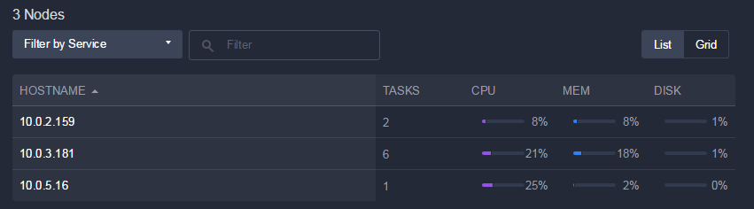

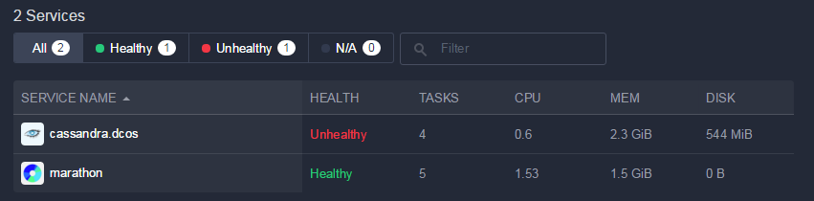

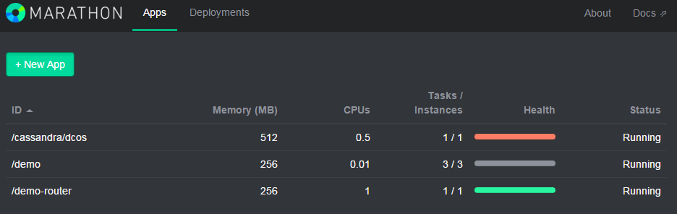

#### Upgrade to 3 instances in SlaveServerGroup 🡪 Cassandra stays UN-healthy!

<https://console.aws.amazon.com/cloudformation/home>



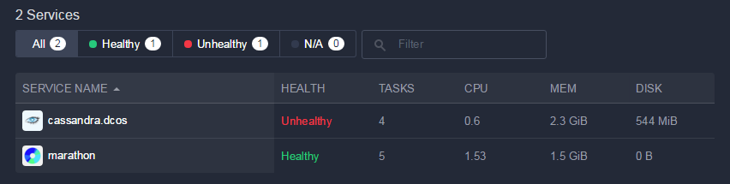

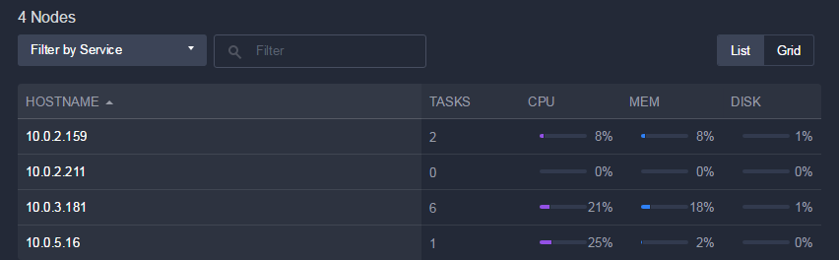

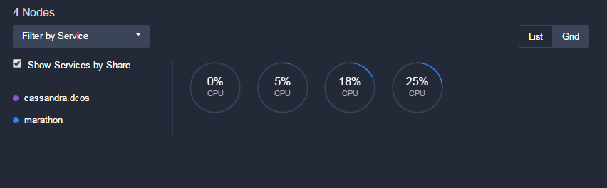

* Likely 2 missing tasks for Cassandra (have been 6 tasks after upscaling to 3 instances, see 1.7.1.3)….
* Cassandara did not recover within 60 minutes…
* Frequent up/down-scaling not recommended.

# Surprising Faults

## Connection Problems

* Everything went well before
* After re-creation of cluster the following error occurred:

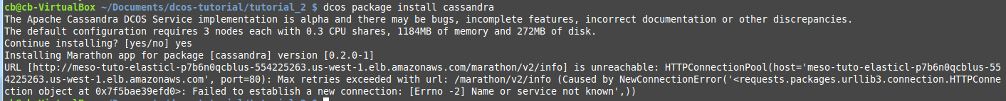

* Reason: Need to re-install the DCOS because the master node has changed  
  see <https://docs.mesosphere.com/install/cli/>   
  information where master node is located is in file $HOME/.dcos/dcos.toml
* Steps to fix:
  + Get master node URL from AWS:  
    <https://console.aws.amazon.com/cloudformation/home>   
    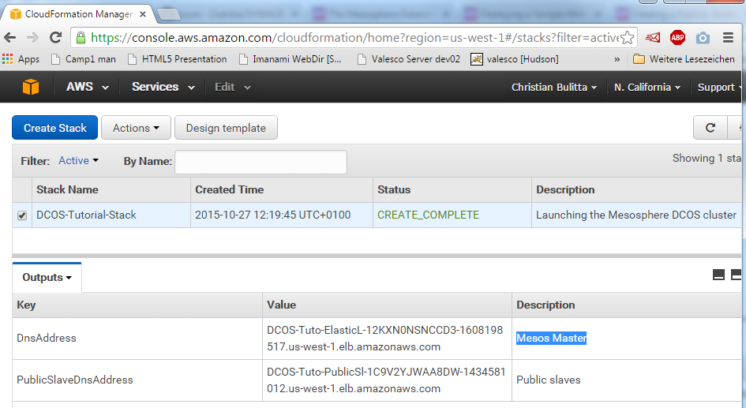
  + Invoke on shell:  
    curl -O <https://downloads.mesosphere.io/dcos-cli/install.sh>  
    bash install.sh . http://<Mesos Master>  
    e.g.  
    bash install.sh . <http://DCOS-Tuto-ElasticL-12KXN0NSNCCD3-1608198517.us-west-1.elb.amazonaws.com>

# Tutorial 1

<https://docs.mesosphere.com/tutorials/deploywebapp/>

Deploying a Sample Web App with DCOS

Errors:

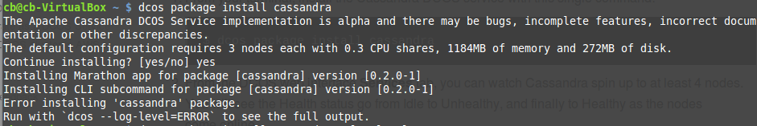

But which?

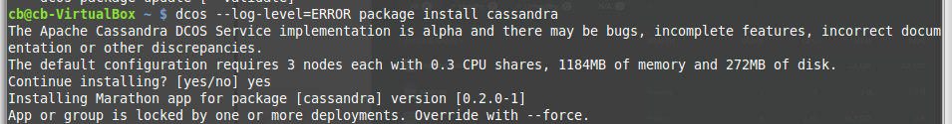

* But seems to be installed somehow:

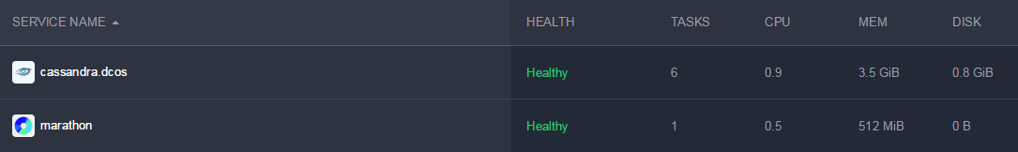

<http://Meso-Tuto-PublicSl-1DV84PC49RTNI-193387908.us-west-1.elb.amazonaws.com>

# Tutorial 2

<https://docs.mesosphere.com/tutorials/deploymarathonapp/> 🡪 No Issues

<https://docs.mesosphere.com/tutorials/publicapp/> 🡪 Issues

Docker image cannot be built :

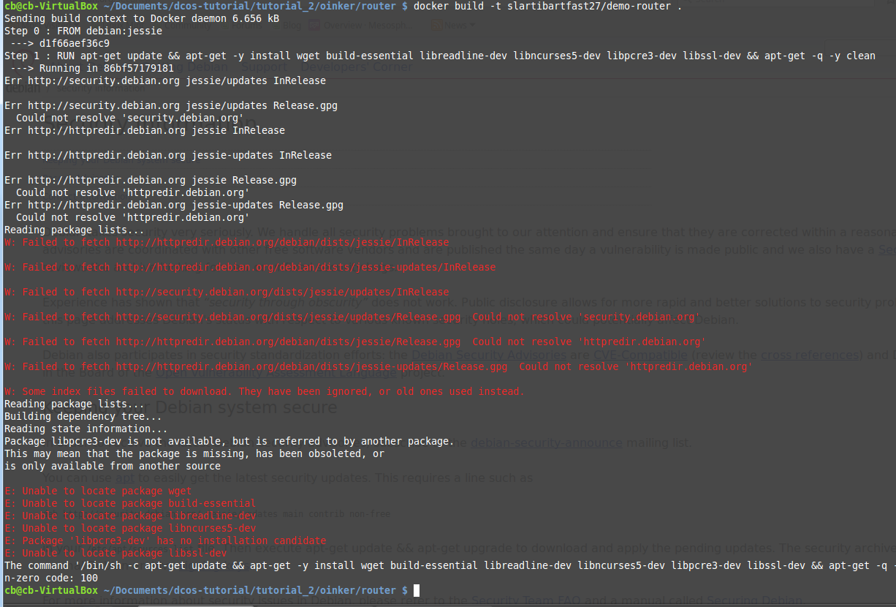

Try with zred (instead of corporate wired network …)

* This works ;-) 🡪 need to use zred for this tutorial

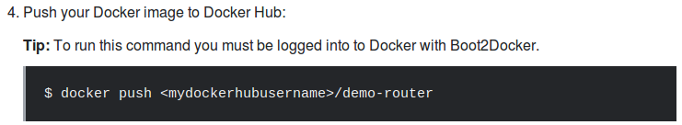

* Does not work:  
    
  🡪 problem was uppercase dockerhub Username  
  🡪 now we need credentials:  
    
  🡪 how do we “Boot2Docker” ?  
  <http://boot2docker.io/> 🡪 Do I really need a own VM just to do docker push?  
  Hope not…   
  Solution: use “docker login”  
  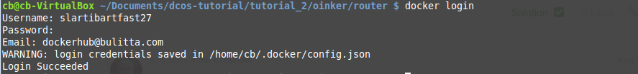  
    
  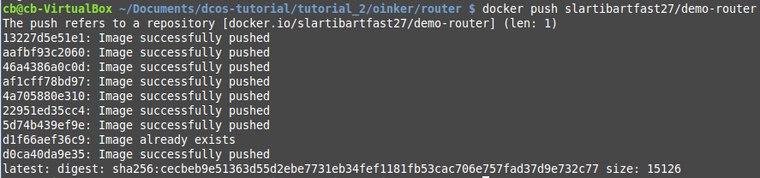  
  🡪 OK, 152 MB uploaded